10. To implement the Expectation Maximization (EM) algorithm for clustering data.
Procedure
- Import the Gaussian Mixture Model.
- Create the dataset.
- Train the EM model.
- Predict the cluster labels.
- Display the clustering result.
Dataset 1: Student Performance Clustering
Study Hours | Attendance (%)
2 | 65
3 | 70
4 | 75
5 | 80
6 | 85
7 | 88
8 | 90
9 | 93
10 | 95
11 | 98
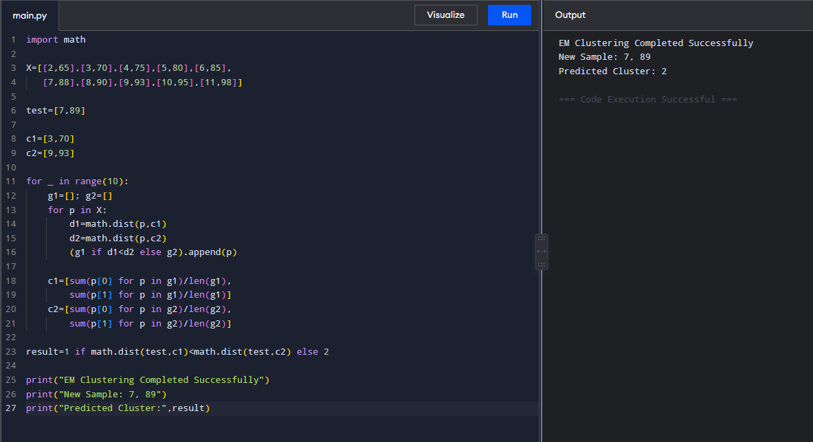

Dataset 2: Customer Segmentation
Annual Income (₹ Lakhs) | Spending Score
2 | 20
3 | 25
4 | 30
5 | 40
6 | 50
8 | 65
10 | 75
12 | 82
14 | 90
16 | 96
Code and Output:
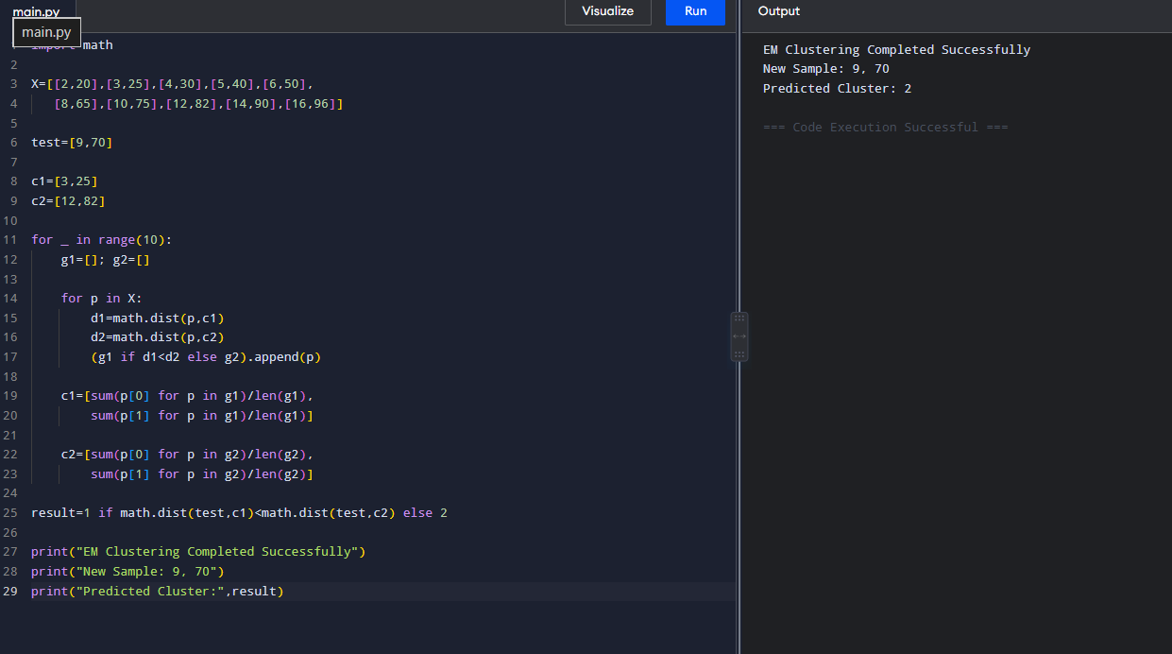

Dataset 3: House Size Clustering
House Size (sq.ft) | Price (₹ Lakhs)
800 | 30
900 | 35
1000 | 40
1200 | 50
1400 | 60
1600 | 75
1800 | 90
2000 | 105
2200 | 120
2400 | 135

Code and Output:
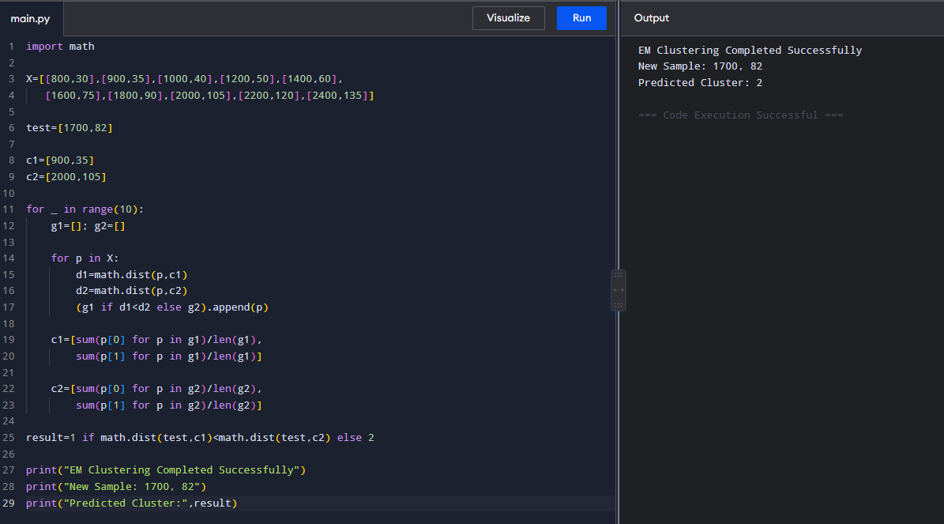

Dataset 4: Employee Salary Analysis
Experience (Years) | Salary (₹ Lakhs)
1 | 3.0
2 | 3.8
3 | 4.8
4 | 6.0
5 | 7.5
6 | 9.0
7 | 10.8
8 | 12.6
9 | 14.5
10 | 16.5

Code and output:
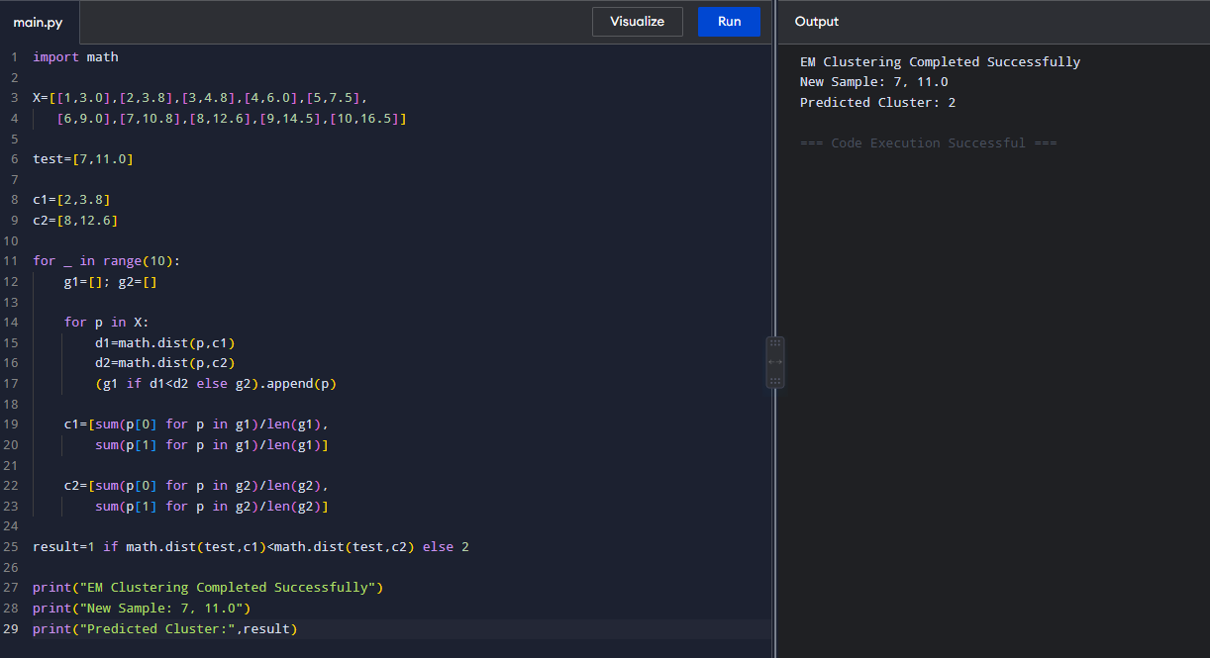

Dataset 5: Vehicle Speed Analysis
Speed (km/h) | Fuel Consumption (L/100 km)
40 | 4.5
50 | 5.0
60 | 5.6
70 | 6.5
80 | 7.8
90 | 9.2
100 | 10.8
110 | 12.5
120 | 14.3
130 | 16.2

Code and output:
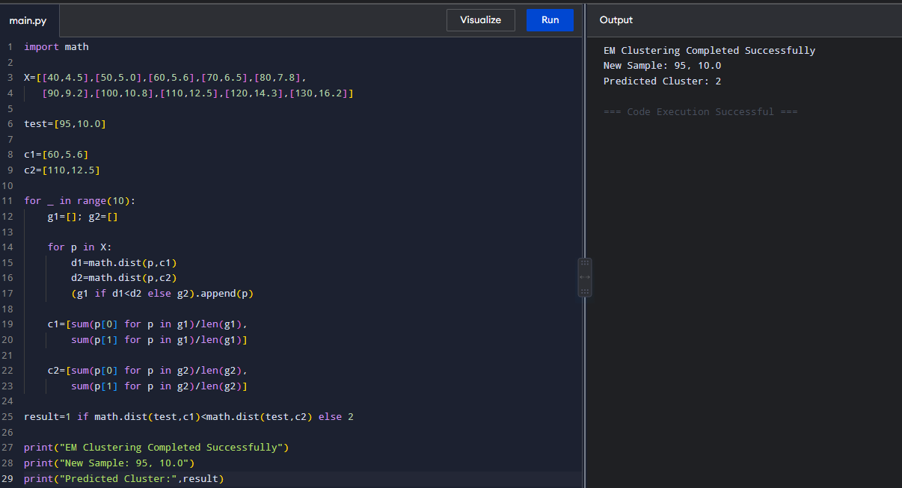

Overall Result:
The EM algorithm successfully performed clustering on all five datasets and assigned each new sample to the appropriate cluster.

